Char Oxidation

The process is modelled in two different techniques.

The first case is when the pyrolysis and oxidation of char reactions happen simultaneously and in second case pyrolysis reactions are completed first and char oxidation occurs later.

The temperatures in both case = **600oC**

Initial char mass fraction is assumed to be 0.01

Observations:

* The char content increases slightly for the first few microseconds and then decreases quickly, and later remains roughly constant for a while.
* The oxidation reactions are in general very fast in the presence of oxygen, therefore we can conclude that if any pyrolysis reaction is conducted in presence of oxygen would leave ash which has low carbon content and would probably consist of mainly inorganics.

Case 1: Pyrolysis and oxidation together.

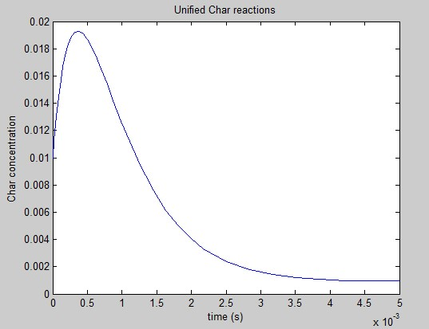

Concentration with time (short term)

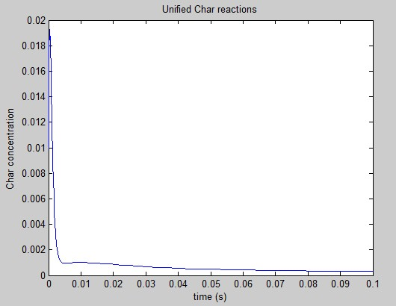

Concentration with time (long term)

Case 2: Pyrolysis precedes char oxidation

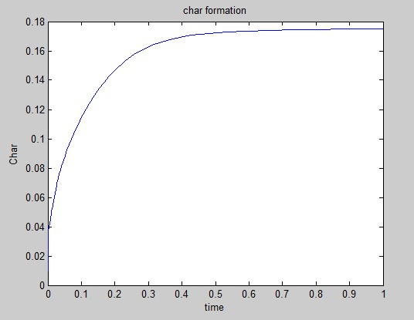

Pyrolysis only

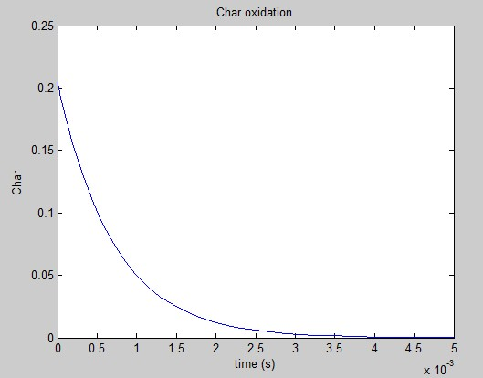

Char oxidation.